Calapan City Tourism Information and Booking Management System

Submitted by:

Panganiban, Arth Thristian A

CHAPTER 1

Introduction
The Calapan Tourism System is a comprehensive web-based application built on the Laravel framework, specifically designed to modernize, centralize, and streamline the promotion and management of tourism destinations across Calapan City, Oriental Mindoro. By providing a dynamic, user-friendly digital storefront, the platform empowers global and local travelers to effortlessly discover hidden ecological gems, cultural landmarks, and native culinary spots while accessing real-time travel logistics and scheduling tools. Simultaneously, the system equips local administrators and tourism stakeholders with a powerful backend dashboard to manage assets efficiently, monitor visitor analytics, and update destination profiles instantly, directly boosting the city's digital presence and driving sustainable economic growth within the community.
Leveraging Laravel’s robust security protocols and efficient database management capabilities, the system ensures a seamless, highly secure user experience that bridges the gap between traditional tourism management and modern digital consumer habits. By transforming how the city archives, displays, and interacts with its historical and environmental treasures, this digital initiative serves as a critical catalyst for localized hospitality, paving the way for data-driven tourism policies and positioning Calapan City as a premier, technologically forward destination in the region.
Objectives of the Project
General Objective
The primary objective of this project is to develop a comprehensive tourism management system that facilitates the discovery and booking of tourism spots in Calapan City, enhancing the overall experience for visitors and improving the efficiency of administrative operations.
Specific Objectives
- To design and implement a role-based authentication system for Administrators and Users.
- To create a management module that enables administrators to add, update, archive (soft delete), and restore tourism spots and categories.
- To provide a user-friendly interface that allows visitors to search and filter tourism spots based on categories.
- To develop a booking management system that enables users to schedule visits and allows administrators to monitor tourism activities.
- To implement a review system that enables users to provide feedback regarding their visited tourism destinations.

Scope and Limitations of the Project
Scope
The system covers the following functionalities:
User Management
- Registration and login system.
- Profile management for both Administrators and Users.
Tourism Spot Management
- Full Create, Read, Update, and Delete (CRUD) operations.
- Management of tourism spot information including location, pricing, and image uploads.
Archiving System
- Implementation of Soft Delete functionality.
- Restoration of archived records without permanent data loss.
Booking System
- Submission of booking requests by users.
- Viewing and Management of booking history.
Search and Filter Features
- Dynamic searching based on tourism spot names.
- Filtering is based on tourism categories such as Beaches, Parks, Adventure and Historical Sites.
Responsive Design
- Mobile-friendly user interface developed using Tailwind CSS.
Limitations
The system has the following limitations:
- The application does not support online payment processing or reservation fees.
- Real-time communication features such as live chat are not included.
- The system only covers tourism destinations located within Calapan City.
- The application requires an active internet connection since it operates as a web-based platform.
Significance of the Project
For Tourists
The system provides a convenient platform where visitors can explore tourism destinations, access updated information, and schedule visits efficiently.
For Local Government and Administrators
The system serves as a modern tool for tourism management, enabling better organization of tourism data, promotion of destinations, and monitoring of visitor activities.
For Local Businesses
The platform increases the visibility of tourism establishments and attractions, potentially contributing to local economic growth.
For the Academic Community and Future Researchers
This study enriches e-tourism literature by providing a practical Laravel framework blueprint that bridges software theory with regional development. It serves as a foundational baseline and strategic roadmap for future scholars looking to scale public sector systems or integrate advanced technologies.
Definition of Terms
Authenticatable – A Laravel trait that enables a model to participate in the authentication system.
Blade – Laravel’s templating engine used to create dynamic and reusable user interfaces.
CRUD – An acronym for Create, Read, Update, and Delete, representing the four primary database operations.
Eloquent ORM – Laravel’s built-in Object-Relational Mapper that simplifies database interactions using PHP syntax.
Laravel – A modern PHP framework used for building web applications based on the Model-View-Controller (MVC) architecture.
Middleware – Software that acts as an intermediary between requests and responses, commonly used for authentication and authorization.
Migration – Laravel’s database version control mechanism that manages database schema changes.
MVC (Model-View-Controller) – An architectural pattern that separates an application into Models, Views, and Controllers.
Soft Deletes – A database feature that marks records as deleted without permanently removing them from the database.
Tailwind CSS – A utility-first CSS framework used for designing responsive and modern user interfaces.

APPENDICES
Appendix A. Entity Relationship Diagram (ERD)
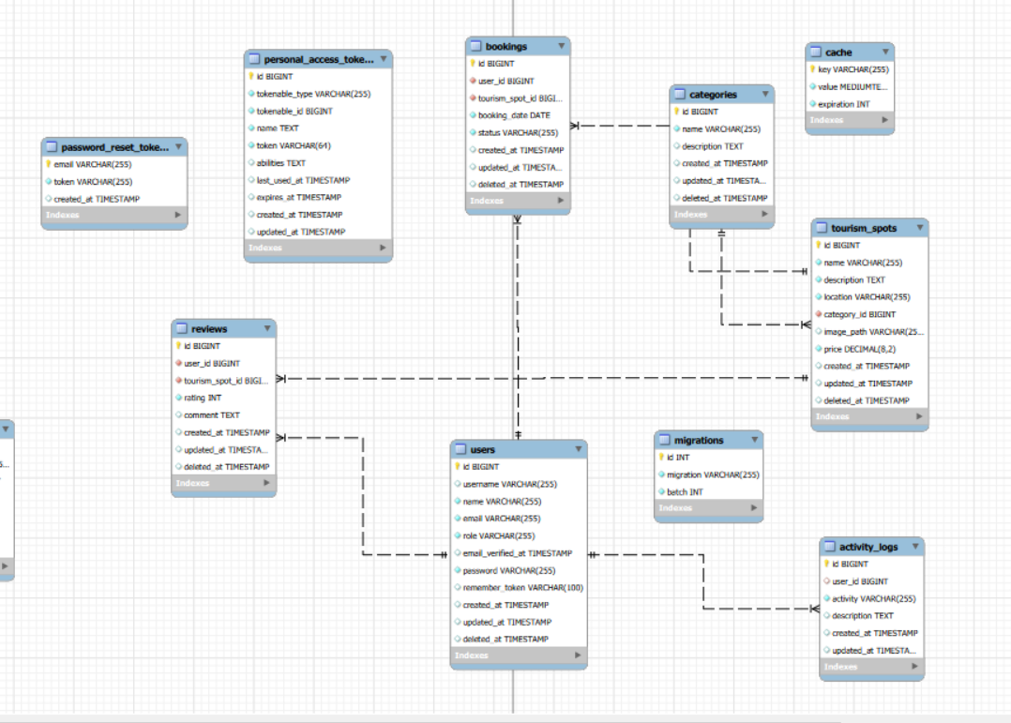
Appendix B. Wireframe Description
Home Page
- Hero section with a search bar.
- Tourism spot cards displaying images, names, and prices.
- Category filtering through a sidebar or dropdown menu.
Admin Dashboard
- Statistical overview showing:
  - Total Tourism Spots
  - Total Bookings
- Sidebar navigation for management modules.
Tourism Spot Management
- Table displaying all tourism spots.
- Action buttons for:
  - Edit
  - Archive
  - Restore
Booking Page
- Booking form with a date picker for scheduling visits.

Appendix C. Site Map
Public Access
- Home Page
- Tourism Spot Details
- Login
- Register
User Access
- Dashboard
- My Bookings
- Profile Management
Administrator Access
- Dashboard
- Manage Tourism Spots
- Manage Bookings
- Manage Categories
- Profile Management

Appendix D. Data Dictionary
Table: users
Field | Data Type | Description
id | bigint | Primary Key
name | varchar | Full Name
username | varchar | Unique Username
email | varchar | Unique Email Address
password | varchar | Hashed Password
role | varchar | User Role (Admin/User)
deleted_at | timestamp | Soft Delete Field

Table: categories
Field | Data Type | Description
id | bigint | Primary Key
name | varchar | Category Name
description | text | Category Description
deleted_at | timestamp | Soft Delete Field

Table: tourism_spots
Field | Data Type | Description
id | bigint | Primary Key
name | varchar | Tourism Spot Name
description | text | Detailed Description
location | varchar | Address or Location
price | decimal | Entrance Fee
image_path | varchar | Image File Path
category_id | bigint | Foreign Key (categories.id)
deleted_at | timestamp | Soft Delete Field

Table: bookings
Field | Data Type | Description
id | bigint | Primary Key
user_id | bigint | Foreign Key (users.id)
tourism_spot_id | bigint | Foreign Key (tourism_spots.id)
booking_date | date | Scheduled Visit Date
status | varchar | Booking Status
deleted_at | timestamp | Soft Delete Field

Appendix E. System Features
- Role-Based Access Control (RBAC)
- Soft Deletion and Restoration of Records
- Dynamic Image Upload Management
- Advanced Search and Filtering
- Booking Status Tracking and Management

Appendix F. Use Case Description
Administrator
- Manage Tourism Spots (Add, Edit, Archive, Restore)
- Manage Categories
- View and Monitor Bookings
- Manage Tourism Data
Registered User
- Search Tourism Destinations
- Filter Tourism Spots by Category
- Book Tourism Destinations
- View and Cancel Bookings
- Manage Personal Profile
Guest Visitor
- Browse Tourism Destinations
- View Tourism Spot Details
- Registering an Account

